Information on tourist spots around Ojiya
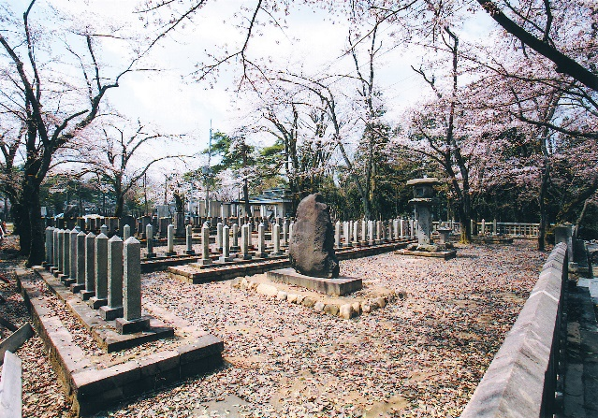
Cemetery of Western Army at Mt.Funaoka

This is the cemetery of 199 soldiers of the western army who died in the battle of Hokuetsu which happened around Ojiya and Nagaoka area in 1868. People in Ojiya cooperated with the western army wishing for a new bright generation to come, so the main camp was located in Ojiya.
At first the government was supposed to build the cemetery, but they faced financial difficulties and couldn’t acquire property. Then some local landowners donated their lands and also covered most of the cost.
Many of the 199 soldiers were teenagers. It is heartbreaking that they had to lose their lives in a place they had no connection to and in such young age.
When their descendants visit here, they are surprised they are buried in a cordial manner and appreciate people in Ojiya.

